Jenkins - From Zero To Hero Become a DevOps Jenkins Master
--------------------------------------------------------
sudo docker images
sudo docker info
du -sh /var/lib/docker
docker-compose up -d
docker-compose restart jenkins
docker-compose down ## deletes all containers
docker logs -f jenkins ## jenkins – is an container_name: from docker-compose.yml
sudo docker exec -ti jenkins bash
docker cp script1.sh jenkins:/tmp/script1a.sh
--------------------------------------------------------

1. Resources for this section

2. Introduction to the course

3. Note: About the Lab

in

4. Start building your Lab - Create a
Virtual Machine using VirtualBox

5. Start building your Lab - Install
CentOs

6. Start building your Lab - Configure
Putty

7. Install Docker

8. Install Docker Compose

9. Download the Jenkins Docker
Image

Hello and welcome back in this Liz.
We're going to learn how to install Jenkyns and we're going to install Jenkin's using Duckery.
That's why we installed daquiri before.
OK.
So as you may know or if you don't know don't worry.
But Duckery uses something called an image and image is like.
And is nap sheared off a conflagration.
So in this case we're going to look for a Jenkin's image which has already all the configuration.
And we just need to run that image and then we will have our Jenkin's server up and running in some
minutes.
So let's head to Google dot com and let's look for Dr. Jenkins image.
We hit enter and then we're going to go to our first resort and as you can see here we have these Jenkin's
which is the official in March for a doctor.
So we're going to copy this command and this command is going to download the image.
So we go here and what we're going to do is we're going to pay this command and we hit enter OK.
As you can see the image is already downloading.
We only need to wait until the process completes and we are almost done.
This is the magic of Doctor doctor allows you to create services quite easy with images.
So you only need to have one image and then you're going to be able to pick up one service pretty fast
and that's cool.
You just need to create an image or look for an existing name and run that image and then you have your
servers up and running.
Don't worry if you don't know Dharker we are going to learn here.
So OK you already downloaded this image but where is this much located.
Well if you type darker images then you are going to see your image here which is pretty good.
sudo docker images
REPOSITORY TAG IMAGE ID CREATED SIZE
jenkins/jenkins latest c1418ce0873c 32 hours ago 577MB
It's a little bit heavy but don't worry.
OK so we have if you must know if you type jocker info and you grab for rude you are going to know we're
Dharker is saving the files.
So this is the location.
sudo docker info
Client:
Debug Mode: false

Server:
Containers: 3
Running: 0
Paused: 0
Stopped: 3
Images: 18
Server Version: 19.03.2
Storage Driver: overlay2
Backing Filesystem: extfs
Supports d_type: true
Native Overlay Diff: true
Logging Driver: json-file
Cgroup Driver: cgroupfs
Plugins:
Volume: local
Network: bridge host ipvlan macvlan null overlay
Log: awslogs fluentd gcplogs gelf journald json-file local logentries splunk syslog
Swarm: inactive
Runtimes: runc
Default Runtime: runc
Init Binary: docker-init
containerd version: 894b81a4b802e4eb2a91d1ce216b8817763c29fb
runc version: 425e105d5a03fabd737a126ad93d62a9eeede87f
init version: fec3683
Security Options:
apparmor
seccomp
Profile: default
Kernel Version: 4.4.0-146-generic
Operating System: Linux Mint 18.1
OSType: linux
Architecture: x86_64
CPUs: 4
Total Memory: 3.741GiB
Name: mint2
ID: 2ZYM:EG7T:VM6R:H57X:SJUM:R27D:KZUQ:ZX7I:ZBY4:5TIL:B5MT:B67R
Docker Root Dir: /var/lib/docker
Debug Mode: false
Registry: https://index.docker.io/v1/
Labels:
Experimental: false
Insecure Registries:
127.0.0.0/8
Live Restore Enabled: false

If you do something like sudo do dash is age and then you give the path you're going to know how much
this pays is that Kurt taken in this case they taking this size because we downloaded this image.
sudo du -sh /var/lib/docker
1,3G /var/lib/docker
Ok cool.
So we already downloaded the Jenkin's image.
Now it's time to run it.
So for that.
See you in the next lesson.

10. Create a Docker Compose file for Jenkins
nano docker-compose.yml
version: '3'
services:
jenkins:
container_name: jenkins
image: jenkins/jenkins
ports:
- "8080:8080"
volumes:
- "$PWD/jenkins_home:/var/jenkins_home"
networks:
- net
networks:
net:

- docker-compose up -d
Hello and welcome back.
The first thing that we're going to do is we're going to create a directory which is going to be called
Jenkyns.
You can create it whatever you want.
In this case the path is as large hum Jenkins and Jenkin's as you can see here.
I just created a directory here.
If a journalist here is the directory in befool pad for a directory is that current directory Pazz this
pad.
So let me just rename this directory because you may be confused so let's rename it.
And we're going to call that Jenkin's data for example.
So the full path for Jenkyns data is going to be less home Jenkyns and Jenkin's data perfect.
These directories empty as you can see because we haven't created anything but we're going to create
things.
OK.
We created the directory.
Now we're going to move into that directory.
We don't have anything here but we're going to create a sample daquiri compose file.
So we're Type VII docker compose that yemo.
This is important.
This name is pretty important so please keep it like this.
And vi is a text editor for Linux.
So we're going to hit enter.
And then we're going to start typing.
Did Doc compose fire before doing a duck recomposed file is they can the script is a definition.
So here we're going to define which services we want to spin.
So in this case for now we want to spin a Jenkin's server.
So we're going to start with this file.
So we say Version 3 that's the current version of Duguid composed don't worry.
And now we say it services.
So in services we're going to define our Jenkin's server and this denken server will have some properties
so we can define the container name container name and where are you going to call it Jenkyns simple.
Now we're going to define the image.
So is a image and then the name that is going to go here.
Is the name that we downloaded in the preview video.
So we type darker image.
And here we have the name.
So we're going to copy this name.
Are going to open up again or Dr. composed file.
And we're going to pay these in here.
Cool.
Oh a pretty quick tap.
If you don't know how to exit of this crane this is pretty simple.
You hit escape then you head shift and the colon key then you press w in Q Which means right and quit.
So we hit enter and you are really quite cool.
So OK we're ready to find a container name and image Waddle's zoo in it.
I'm going to leave you does Tim played here and this Tom played.
You can actually just copy and paste it if you run right.
Use it or you can manually type.
There is no problem.
So we're going to find the poor it's what our good port.
So we're going to say port and we define an A right of port that we're going to say that we want to
expose the port of Jenkin's using the port 80 on our machine and we're going to map that port internally
to the container on port 80.
Don't worry we will take a look on this later.
What else do we need.
We need to Baalim what is a Baalim.
OK.
You must know that in Dharker when you create a container when you use Pin-Up your service all the data
which is within the container is going to be destroyed if you don't save that data into a volume.
So we say volumes here in this case and we're going to say OK we want to create a folder which is going
to be called Jenkin's folders.
So let's use the coring part for now.
Are you going to say PWT which means PWT a career path.
And we're going to create a folder which is going to be called Jenkin's home for example.
And we are going to map these for other.
OK.
First we need to create this folder in our machines already in a copy of this
and are you going to go out of Bam and we're going to create a directory here.
So we click make your home make sure you don't put the lash make Jenkin's hum.
Hit enter.
Any of you do.
Unless you should see Jenkin's home folder at the same level of the docker-compose file.
So OK the full pop Ferdie's is the PWB which can be represented with this variable.
You do an EC2 loops.
So this is the correct path plus your four letter to folder that you have just created and this is the
full path as you can see.
OK so where are you going to get back to work Dharker compose file.
And we are already defined as this is the host Baalim.
Now we're going to map it to a container.
So how do we do this within the container.
The darker image eases these folder to his tour of the file.
So where are you going to copy the location where you put a calling here.
And then we paste the location.
So we're saying OK Doctor please whatever you are right here which is going to be all of the files for
Jenkyns.
Please save those files in the directory that I have just created.
Cool.
And now we need to define a network.
So we say we one this to be in the network that we haven't created the network net.
So let's go here in the same text file at the same level of services where are going to create a section
which is going to be called networks networks.
We put a call on an underneath of these.
We're going to create a net network.
So OK we're saying Please Doctor create a network using these instruction which is going to be called
net and then we're going to use that here.
And where are you going to include the Jenkin's server or the Jenkyns service within the network.
So that's pretty cool.
I think this is everything we need.
We're going to save the file and we are done.
So let's recap what we just did.
And if we do that cat in the duck recomposed GMO file We're going to see that we're using a version
3 of Dr. compose.
We have defined a service.
Its name is Jenkins they contain our name is going to be Jenkin's the image that it's going to use as
the Jenkin's slash Jenkins image.
It's going to export the port 80 80.
It's going to save all the information in these folders that we created.
And this is going to bind the service into an Network which is called Net Envy's network is being created
here.

11. Create a Docker Container for
Jenkins
Hello and welcome back in this video we're going to start our service our container using doctored to
spin up the Jenkin's service.
So so far we already created the doc recomposed file and we created a directory here where we're going
to save all the files.
So remember that we define a volume here and we're saying OK Doctor please.
Everything that is within the container in this location please save this in this folder and this folder
means this folder.
So if we take a look on the folder itself we see that we don't have any data yet and that's normal because
we haven't created anything.
So please make sure the DS folder has proper permissions so Jenkyns can write.
And what do I mean by a proper permissions.
Make sure that that user 1000 can write to these folder.
And what's the use at 1000.
So in Linux we have IDs and as you can see these user Jenkin's user has the user id of 1000.
So we're going to do a suit to change our 1000 call on 1000 into these folder.
So Jenkin's harm we're going to do it recursively.
So OK when you leave this you will do an L L and you are going to see that the user the Downer's Jenkyns
and the group is Jenkyns.
This is because the container uses the ID law of to write to any of you have an order ID you are going
to probably have a never.
So please make sure that you read this command before is pinning up your server.
So okay we're really gave it permissions.
We only need to do this once.
I mean this time in no more.
And once we gave permissions were going to pin up this server doing a daquiri compose app Dashti and
what is going to happen here is the doctor is going to create the service reading the doc recomposed
the Phoenician theater and if we type.
Dr. Pierce we're going to see this server running here.
So this is it daquiri container behalf as Pan up our server using Duckery.
You can list your containers using daquiri.
P.
So as you can see this is actually working like a charm.
Cool.
I will type doc Curlylocks dash F and this is going to show me the locks for ascertaining container.
Remember that in our definition of the Dockerty composed file we said that the container name is Jenkin's
So we do a darker loves dash.
- docker logs -f jenkins
And if Jenkins we hit enter and as you can see here this is what we are hash.
We're going to use these later.
So for now what we're going to do is we're going to hit the IP address of our machine.
Do you remember the IP address.
So we're going to grab this IP we can pick up here from you remember we can click here.
Load and then we will have the AP.
So we're going to copy these IP and we're going to paste it into our browser so we paste it.
And we're going to have an error.
But if we do a call on :8080 and then we hit enter it again we are going to be a press centered on the
screen that tells us hey I am Jankins.
Well finally we have Jenkyns installed and Jenkins wants to make sure that we are the owners.
So we need to introduce your password.
What's the password.
Well the password is pretty simple.
You go to put me here.
You do a duck Curlylocks dash F and you will see the password in here.
So this is the password and or even a copy of this.
Remember to copy and put in your users do a double click on the thing you want to copy and then you
paste it normally here you pasted and then you click on continue.
Pretty simple.
So now as you can see here we are presented with a screen that says customized denken.
So what do we do here.
I would suggest you to click on the button that says insults are just appliance.
We're going to click on this and Jenkyns.
Where you going to see these later.
Jinking has a lot of plug ins and a plug in is nothing else but like a tool an extension for something.
So Jenkyns it's quite powerful but you can still plug in in a plug in is going to give you additional
functionalities for Jenkyns.
So in this case we're going to install the suggested plug ins by Jenkyns because for sure we're going
to need it in the future.
So this is going to take a while because it needs to connect to the Internet and then download the files
and install them into Jenkyns.
I will pause the video and now will come back when it has finished great.
So did download already finished.
And now we have a screen here that tells us to create a user and as you can see here it says OK please
create the first admin user.
So we're going to call it admin.
Or you can call it whatever you want.
We're gonna give you the password.
Please give us trank password.
I will give you the one two three four one two three four.
And actually if you want to do for to everything.
OK.
So we're going to give the full name.
Let's say that this is going to be Jenkyns at man and let's say that the male of this guy is like Jenkin's
at gmail dot com just to say something.
OK.
Don't click on the save and continue.
We click on never here and here this is going to ask for a day you are all.
So for now we're just going to leave it like this.
We click save and finish and then we are done.
Finally we click on start using Jenkyns.
And here we have the screen that allows us to lug God and lock in.
So if we click on Loog out here then we put the credentials that we created ad man and one two three
four is a puzzle where we can click on Kyp mayor saying then let's click it and then let's hit design
button.
Cool.
So here we are in the Jenkin's dashboard and then we're going to start having a lot of fun with all
of these features tools and icons that you can see here.
It's a dummys.
Any video.
And see you in the next lesson.

12. Create a local DNS for your
Jenkins server
nano /etc/hosts
Hello and welcome back in this video we're going to be changing gears I pay the kids we're going to
start using a DNS local DNS.
So for doing days we need to open up a notepad and we're going to click on recked click Run is that
minutes later when we are heater let's select the final occasion open.
Let's go to your Windows partition in my case it's Windows see.
So let's look for Windows.
Let's look for system 32 here.
OK let's look for drivers and drivers we click on each PC.
And after that here we just click on all the files.
When we're presented to DS We're going to choose the hosts file and what we're going to do is to graph
the IP address that you can select from puti or from your web browser and we're going to paste that
AP here.
Please don't include this HDB.
So the IP only and after that you can give a name that you on any name it's OK.
So for now we're just going to say like Jenkin's out local and we're going to save file save after that
you can close it and you can open a new tap and you can type Jenkin's that local call on ADHD hit enter
and Magique you have not created a local DNS.
So for days we can reach Jenkin's using these.
And even we can modify our poor decision in order to change their IP and start using the DNS.
So if you want to you can use instead of using the IP address here you can use the DNS that we have
just created which is Jenkin's that local.
So I'll see you in the next PDU.

14. Learn how to work with
Docker and Jenkins
Ok cool.
So now that we have configured everything in that we're using a better interface.
We are going to start learning how to use Jenkin's remember that if you do an L as you're going to see
these folder which is jinking Zeta we created that for before.
So just go ahead and change directory to that folder and if you need LS you're going to see the doctor
compose for you are going to use these docs recomposed file a lot because remember that this file contains
the definitions for the service itself.
So if we go to the browser now and we reload we have the service up and running.
But what happens if we want to stop the service or if we want to reboot or machine then to stop the
service we need to do at Duckery compose stop.
And this is going to stop the service itself.
So if we reload here the service is no longer alive.
If we do a duck croupiers you see that there is no container running.
Therefore you have a network here.
So if you want to start your service you do at daquiri compose start and then you do a ducker appears
and you see that the container is actually up and running.
So if I were reloading here it takes some seconds for Jenkins to completely Buddh up.
So that's how you work with this.
Maybe if you want to use service you are going to deduct or compose maybe a restart Jenkin's which is
the name of the service that you want to restart.
This is going to stop it and then it's going to start to go back and what happens if you want to completely
delete your entire service.
So.
OK.
You are going to do a daquiri composed down and this down is going to delete everything related to disserve
is that it's not going to delete.
Well we say from the volumes do you remember divulgence if we take color darker compose file we see
that indecorum pad we have a volume which is this one.
And if we do analysis here we're going to see all of the files that belong to Jenkyns.
So if we recreate that this service this is going to look for the files in this folder and then is going
to map those files into that container itself.
So let's do this joker composed Abdul-Hadi creates the service or recreates the services.
So if we do that Dr. Pierce does services up and running so let's keep the browser and see what happens.
So as you can see Jenkins is just getting ready to work and we should have all the configuration that
we have already done like installing plugins or configuring the admin password and all of that stuff.
So these videos for those guys who don't know how to use Dharker or for people who have never used doctor
before and don't know how to use Dr. compote.
So that's pretty simple.
Does the doctor compose up to create a service or is recreated a stop for a stop in it start for it
start to narrow and down for delay in it.
So this is pretty cool.
Our Jenkin's services are really ready to accept connections.
So we kind of start playing around with this so see in the next lesson.

17. Introduction to Jenkins UI
Hello and welcome back here we're going to have a look at the Jenkyns you guys so you can get used to
this because we're going to be using these a lot.
So let's give the admin user that we created 1 2 3 4 for the password.
And let's click on the kibbitzing bottom line again and then you're going to see this screen for the
Jenkyns dashboard.
OK this is perfect.
So here we are.
And let me introduce you to Jenkin's dash for it and we have here a lot of options that we're going
to look in the future in these cores.
So here you have an icon which is for creating new items new tasks and more.
We have a lot of styles here.
Don't worry we will have sections for days.
Here we have people it means who is actually allowed to log in to do things to create jobs to deliver
jobs where you can configure everything and you are going to learn how to create users restrict permissions
and more.
Here we have a real history.
Our tasks have histories So here we're going to see the performance we're going to see how many tests
fail how many task when succeeded and more.
So here we have managed Jenkin's icon.
We have more things don't worry about this error we're going to fix it in the future.
This is because our DNA is here we have the system we have things for it.
Configuring security for configuring credentials to install plugins.
We have a lot of things here and we're going to go through all of these in decors.
So here we have more things like credentials to manage sensitive data like passwords keys or more and
well I think this is that.
Q summarize for the Jenkins dashboard.
So in the next video we're going to start playing around with all of this items and we're going to learn
how to use them.
So see you in the next lesson.

18. Hands On! Create your first
Jenkins Job
Hello and welcome back OK in this video we're going to create our first map.
It's not going to be your job.
It's going to be pretty simple because it's our first job in the future we're going to do more interesting
things.
So to create a job we can either click here or create a new item.
So let's click on to create new item and now we need to give it a name.
So let's say that we want this job to be called my first job.
That was my first job.
We're going to click and freestyle project which is a simple project and we click OK.
After this you're going to see there's a screen with all of these can be green.
Don't worry I know it could be like overwhelming or something but it's pretty simple.
So the first thing that we're going to do or a difference in that I want you to keep in mind is that
a task is in Jenkin's called a job.
So you're probably going to see everywhere people using the concept of job in a job is nothing but a
task something that is going to be done.
That's a job.
So we're configuring here a job or a task.
But the concept in Jenkyns is a job.
So here in the Bills section we're going to build Stabb and we're going to look for execute command.
So I want to show you one thing and this is that these shil refers to our virtual machine but not entirely
to our virtual machine.
Remember that we created at container in here and these container actually has the Jenkin's service
up and running.
But if we look in our machine I mean outside of the container there is no Jenkin's server.
We don't even have Java installed as you can see.
But if we go inside of their container doing the correct section Dashti Jenkin's and asking for a bash
sudo docker exec -ti jenkins bash
terminal we hit enter and if we type Java you are going to see that we have Javins or heater we can
even do a Java Dasch version and we have a Java insult within the container.
So let's make this clear.
We have our virtual machine which is nothing else but like the house of that container and that container
which can be placed using Dr APF is the service itself.
So as you can see when we do our Duckery except the terminal actually changes it's a perience.
For example in the creative file coach Hello slash stamp slash hello you're going to see that this file
is is going to be created only within that container.
Hello.
But if we go out of that container and we look for the same file these file doesn't exist.
So please keep in mind that everything that's going to happen and.
Jenkins Yup we'll look cure within their container.
I mean we've seen the darker expect Dashti.
It's not going to happen outside.
Not here but everything up would around every command anything is going to be running within that container.
It's time to start running our job.
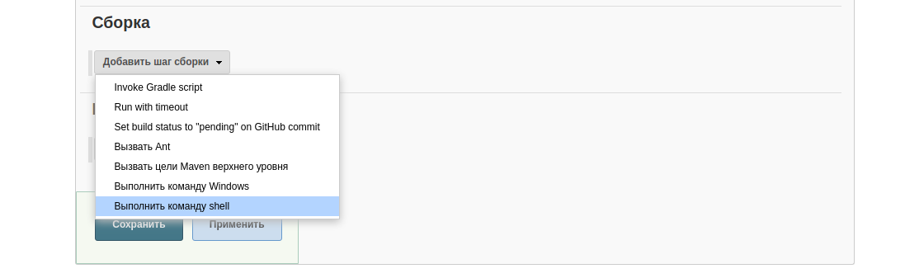
So let's say echo Hello world which is you know the most popular cool for beginners in technology.
So let's click on Save here in after we say if that's click on.
Now they're built but on means viewed in a project so for now if we go here.
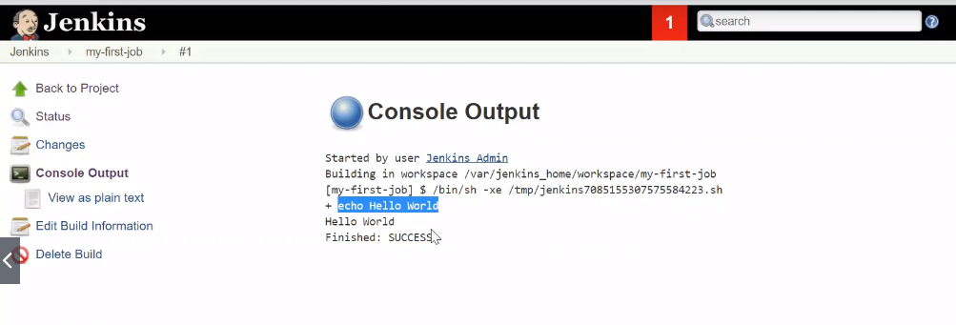
Console output we are going to see that our job executed took says Phlip printin.
Hello world.
So remember what we just did is to create and configure Jopp.
We added it step here as show step and then we said take him in kill hill work.
We saved this and then we clicked on the Beeld Nah burning.
So here we have a bill history we can just go into the number of the execution that we want to know.
Click on the console.
And then we have these output which means that the job executed correctly.
So you already created your first.
Yup cool.
Remember these job has been executed within the container not outside.
So having said this.
See you in the next lesson.

19. Keep playing with your first
Job
Kilo and work him back.
So in this video we're going to be playing weed our job off they job that we created in the previous
lesson.
And I just wanted to tell you that you can go to the Jenkin's home whenever you want.
Clicking on the Jenkin's button here.
So we're going to click in the name of our job and we're going to go into the configure section.
And as you can see we're again presented with this a screen that has all of that configuration.
And this is our current configuration.
So we're going to make this job more dynamic.
In Linux we have a cool command which is the date command.
So let's head to our virtual machine let's go inside of that container.
Remember that we are outside of the container because if we type Ducker P.S. We can see the container.
So we're going to go to the container except Dashti.
Jenkins Bash and here we are within the container as you can see.
This crane looks different.
So if we type in the date command here as you can see we have an output and that output is nothing else
but the current date and time.
So there is actually that it returns day command.
But what happens if you want to execute this command and I want to have text with this command for example
I want to say the date is and then I want that result of these date.
So how do I do this in Linux.
That's pretty easy employ you use the echo command and then you type your string like for example current
date is and then you want to execute the commands.
echo "Current date is: $(date)"
Current date is: Wed Sep 11 11:01:02 UTC 2019
How do you execute the command.
You put Azango are here and then you put parentheses within the parentheses.
You'd type the command through on is good for example.
And as you can see it say it's current date is and it returns the value of the date.
Come on.
Which is pretty useful for doing whatever you want to.
I could say a note or a command like QMI for example and they could change.
You know they command and I want to say who am I.
For example.
And as you can see it's actually given the same text but returning different values based on the command
that I'm executing here.
So let's keep it like this with the date current date is this that's a current date and time cool.
So this command is actually awesome So we're going to copy this command.
And as you saw here on the job definition we have a shell.
So this is actually the same shell as this one so you can freely copy and paste the command that we
typed in the previous terminal in this terminal.
And this is going to work the same way.
So let's click on the safe and once you have that configure you click on Bill now and then you go to
that job.
Console output and then you see the output of the is which says current time current date and time is
the output of Dick Kamen.
Cool isn't it.
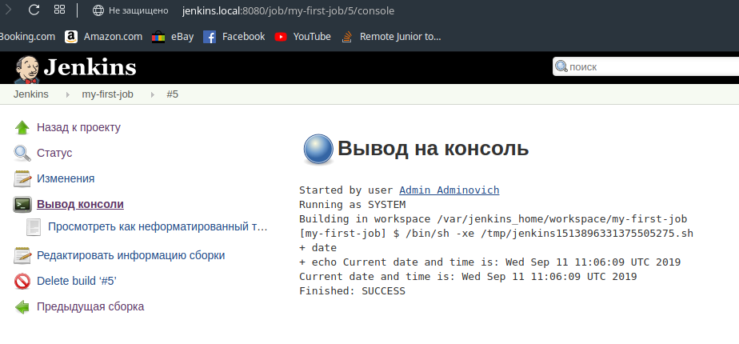
So for example here you are saying at 37 which is the second.
So let's hit big old ones again and let's see if there is any difference.
Where are you going to go here into debil history.
Job number four.
Click on console output and heater.
We're going to see that the day actually change the second change so there's means that Jenkyns is actually
being execute in their command.
Whenever we ask for it.
So this is pretty cool.
You already know how to use linux command within your.
Jenkins Yup and printed with text which is pretty useful sometimes.
So I'll see you in the next lesson.

20. Redirect your first Job's output
Hello and welcome back in this video we're going to learn how to redirect output in Jenkyns.
So in bash remember that you are going to be working with bash because in the job definition if we go
to configure what do you find as shell so shell is exactly the same thing that you are.
BASH command please.
Again remember that we are within the container.
So if you are not within the container go ahead and jump into a container with these commands.
Cool.
So now in bash we can use barrel's a variable is nothing like name.
And for example my name Ricardo.
So if I now do an echo for a name I will have these balloting here.
We want our shell to say Hello Ricardo the date and time is the output of the date.
C'mon how do we do this.
Pretty simple.
We do an echo and we say for example favorable with US dollars in here which is the variable that would
you vyne up your name.
So we say hello to the name and then we say the current That's the current date and time is the output
of the date.
Come on.
Pretty cool isn't it.
So we already knew how to do it is.
But this is something new using variables in bash.
OK.
Nice.
If we copy and paste these for Howard Jenkins job this is going to look exactly the same thing.
Oh but probably this is going to fail here because the variable doesn't exist.
So we need to define the variable map here.
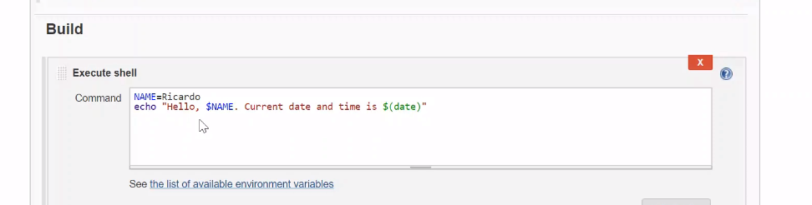
Same name equals to Ricardo.
Cool.
So as you can see this is exactly the same content that we wrote on our terminal.
So if you want to test a Jenkin's job before running the job itself you can copy and paste the comments
to your terminal normally.
OK.
So let's save this and let's execute this job.
So we click on build now and we are going to see what happened.
So if we head to the Butte history to the last execution console output we're going to see the output
that we were expecting.
NAME=Max
echo "Hello $NAME! Current date and time is: $(date)" > /tmp/info1

So it says Hello Ricardo.
Current date and time is the output of the date.
Come on.
Pretty cool.
But now what happens if you want to redirect that data into a fire.
How do we do this.
That's pretty simple.
We put design which is a redirections signing bash and then we give it a pad like for example Tam and
we say in full for example here ENTRAR.
And as you can see nothing comes in determiners our response.
But if we take a look on these file cats lasht damps lashed in full.
We're going to see the content within the file itself.
So this is pretty cool and we're going to do this from Jenkyns So let's remove the file that we just
created and if we do a cat to this file the file is no longer available because we already deleted it.
So now let's copy this command for the shell in here.
Let's click can configure let's delete our current configuration and let's pays the new one.
And as you can see we're redirecting these into a fight.
So OK let's click on safe and let's click on build.
Now if you see the built get to go to their number console output and as you can see the job actually
finish as it sits.
So now let's go to our container and let's look for a data file.
And as you can see it is perfect.
The file is actually being created from our Jenkin's job.
So for example if I removed the file again I do I cut the file doesn't exist anymore.
Verify Beeld.
Now the job.
Once again it's going to be Mark as succeeded.
And if we open the console output it says success and if we take calls on the file the file already
exists because the job created and this is the important part about it wanting to tell you as we're
using docker to host the service all of the files that we created are going to be saved within their
containers.
So if we go out of the container and we look on CAD temp info we don't have that file because it's a
completely different file system.
But if we go within that container then we have a fire that's cool.
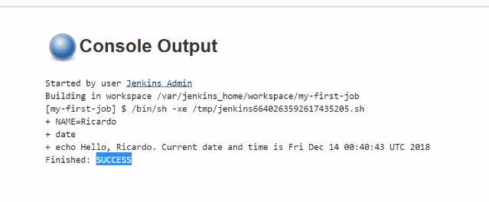
And remember that you're Jenkin's container is a completely isolated process with it's sound or Purton
system in Linux distributions or that's why you can't see the file on your host.
But don't worry to solve that if you want to share files with your hosts.
You can use volume's we're going to see that later.
But don't worry for now.
Just keep in mind that the files that you are creating are being created within the container and if
you go outside of the container you are not going to find those files.
So this is said Ferdie's video.
See you in the next lesson.

21. Learn how to execute a bash
script from Jenkins
Hello and welcome back in this video we're going to learn how to execute on the script.
JENKINS So to achieve this.
The first thing that we need to do is of course to create in a script.
So let's head into our virtual machine.
Remember that in this case we we're outside of that container because we're going to create a sample
file.
So if we go inside of the container as we have learned this way and then we type B which is a text editor
we're going to have a natter and this is the because containers normally only half what they need.
So for example in this case Jenkin's only half packet is triggered into Jenkin's shooting have any order
package like network tools or elders because a container is meant to do only what it is meant to do.
That's why we're going to log out of the container and we're going to create the file here outside of
the container.
So let's create a simple script which can be code like a script that is age and remember that to type
in Pudi you need to press the letter I call.
So normally in Linux or when we are creating the scripts the first line informs which interpreter are
we going to use.
In this case we're going to use bash.
So that's why we're marking has been bashed.
So let's start with a sample script that is going to accept parameters and it's going to print out the
name and the last thing for one person.
So these would be like a..
Hello.
And then it's going to receive the name of one person and then that last name of that person.
!#/bin/bash
NAME=$1
SURNAME=$2
echo "Hello, $NAME $SURNAME!"

So if we exit this is crap like this what do you think that's going to happen if I just go ahead and
you and I try to execute this script.
I will have.
The first error here.
OK to fix this we need to give executable permissions to fire and to do so we need to execute a command
change mode plus X which is going to give executable permissions to the file to then try again.
And you are going to see it.
The only one thing that comes is the helo.
So what we want to do is like for example we are going to call this a crib like this.
And then I want to pass my name and my last name in the script.
So this in this case should print these BERNHOLZ saying hello name and last names respectively.
So let's modify our script and lead at pedometers.
So in Bashan rhomboid parameters are represented with a dollar sign number one for the first parameter
dollar sign.
Number two the second parameter.
So on and so forth.
So in this case we're going to say that the variable name that we are mentioning here is going to be
a reference of the first parameter.
Cool.
So we're going to say that the last name that we're referencing heater it's going to be the Valley of
the second parameter that we are going to reset.
So that's like this.
And OK let's save this and let's execute this crypt again.
And as you can see cool it's actually it returning devalues that we are passing to the script itself
to cool.
Now if we want to execute this from Jenkins What do you think we need to do.
As I told you we are outside of the container which is completely isolated and different file system.
So our container can't see this file unless we copy that file to the container in the future.
We're going to learn how to use volumes and Ducrot to share data between the host and the container.
But for now that's just go ahead and copy the files that we just created to the container.
So for example let's say that we want to copy the file which is called the script that SH.
So we got Kurt C.P the name of the file that we want to copy.
docker cp script1.sh jenkins:/tmp/script1a.sh
Then the name of that container where we want a copy.
And then we put a call on and the full path.
So let's say that we want this to be call slushed slash script that is default pop.
So if we hit enter and then we go inside of a container like this and we take Culligan Tam script which
is the location that we defined before we are going to find easing here.
Pretty cool.
So we have our script here.
So how do we execute this cool.
We just take this full path and executed inside of the container.
And we are going to have an empty answer as you can see because we're not passing any promotors.
If we pass this then we're going to have both of the parameters in here.
So cool let's copy D-pad for a script.
Let's go to our job.
Let's click on configure and let's execute that as crib from the Jenkins shil.
Do you know how to do it so if you want do it before I do it otherwise I'm just going to do it right
away.
So it's going to be pretty simple as simple as it is we're just going to copy and paste this the path
and then we're going to pass the parameters.
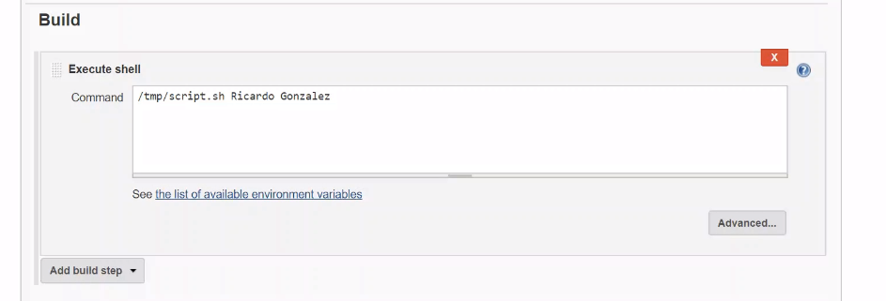
Simple as that.
So you can just click here on safe and then if we build now what it's going to happen.
The Jenkyns is going to go to the file read this crap and it's going to pass the parameters that we
are passing in the shell and in the output as you can see we have the expected output.
Cool.
So again what happened here.
Jenkins from its shell actually took the parameters that we passed and dread them and at the same time
passed those parameters to the script.
We can do it pairs in various roles as well.
So we could say like name equal to my name and we could say last name equals to my last name and then
what we're going to pass here are diverse.
So we say like name and last name as you can see here.
And the output should be exactly the same.
So let's go ahead and save it.
Let go and click on the build button.
And as you can see we have an error here which is pretty cool.
We made a typo and what is that typo.
Can you spot it.
So the type it's pretty simple.
We define as easy here.
We're given variables but in this case we have any space here which is a problem.
So if we go ahead and fix that and then we click on safe and then we build it.
Now we're going to see that this is going to be blue again.
So what happens in Jenkins is that whenever an execution fails the caller of the real history it's going
to be red and it's going to be marked as failure.
But if it doesn't fail then it's going to be marked as X's and the color is going to be blue.
If we go into it comes out here and we take a look on the response we can see that we're defining the
variable name the variable last name of that we're passing those variables as parameters to our main
script.
And then the output is exactly as we were expecting which is pretty cool.
So OK this is it first is what you see in the next lesson.

22. Add parameters to your Job

Hello and welcome back in this video we're going to learn how to use parameters in Jenkin's.
So if you remember in the previous VDU we were creating parameters in bash so we were passing those
parameters coded.
So if we go to the configuration of our job and we take cure if we wanted to modify a parameter we would
need to change the parameter to for example something like Tom and then a last name which could be Smith
for example and then if I click on Save and then I build now the Joffe The output that we could expect
is something like Hello ton's med and that's perfect.
That's what we were expecting.
But what happens if we don't want to count your day job to change the parameter.
We want to be able of dynamically set the name that we want to greet.
So let's go ahead and configure our project and in these part is where the concept of parameter in jinking
comes in to their rescue.
So if we go here in the first section in that general section of that configuration for a day job we're
going to see a lot of options here.
But for now we are just going to choose the option that says this project is parametrized and then we're
going to add a parameter which is praise.
We have a lot of parameters here.
Don't worry we will see them later.
But for now let's use normal string parameter because for now we all want to pass the name and
the last name for the person that we want to get.
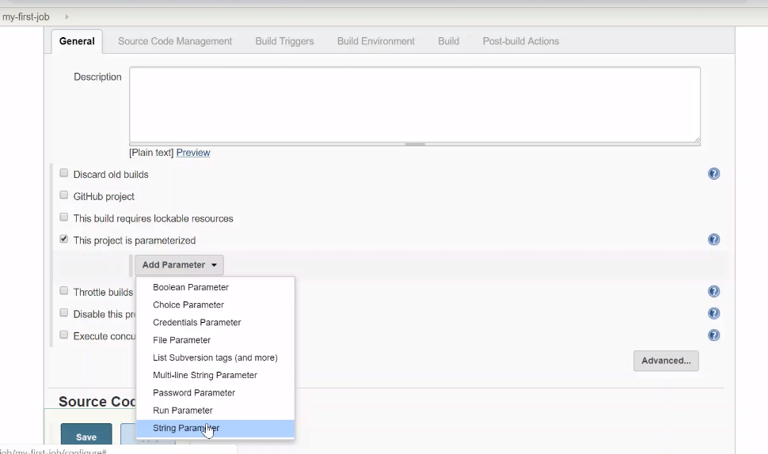
So let's say that we want the name to be name.
So this means the name of the pedometer.
In this case we want to call it as name so let's call it different that you can see it first name for
example and then we can give a default value if we want.
If we don't want don't we just leave it empty Let's go ahead and give it a default dollar with my name
and now we're going to add a second parameter strength barometer again and we're going to now use a
second name of that person.
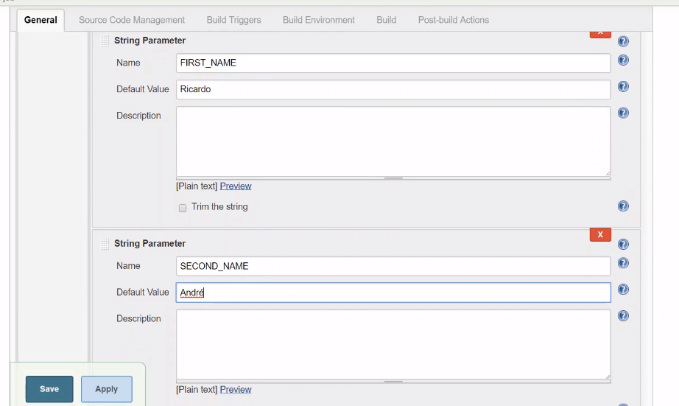
So it was a second name and that we can give it that the full value.
So in my case let's give you my second name.
As you can see here.
So there is something that I want you to check here and this is the name the name means the name of
the verb for the name of the parameter.
So we're going to be referencing these names in our scripts.
So for example we're going to say hello first name and then it's going to take the value and then we
can say hello second name and then it's going to take this value.
So let's go down and let's modify our current configuration let's select diesel and let's run a simple
hello to the name that we are passing as a parameter so we can see EKU Halo and then we're passing a
first name parameter that we create it and then we can pass the second name parameter that we created.
So if you see these are the names that we're using first name and second name so cool.
We are saying hello first name and second name.
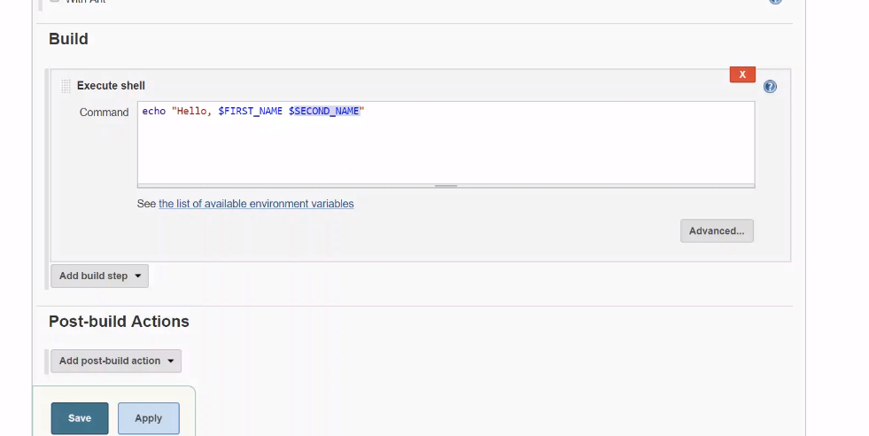
So let's go ahead and save this.
And now if you see the Bubo already change it now is built with parameters.
And what's going to happen if before executing the job.
It's going to ask for these pedometers So here is the first parameter that we created.
And here is the second named parameter we created.
So we can just leave the default value so you can see here and let's click on the build button.
So if you see the console output of this you're going to say this is not the up.
Is the third.
In my bed if you go here and you go to the console output you are going to see that Hello Ricardo which
is my first name and second name.
Cool but what happens if now we want to read not a person that's going to be easy but we're going to
say for example Hello Tom and then do that the second name I don't know that say Adam or something like
that.
And then click on Vote Now.
So you're going to see this is pending.
And cool.
We already have this execution.
So let's go to the console output.
And as you can see the name already change only by modifying their parameter before executing the job.
So Vael Dean jobs with parameter is actually quite powerful because we can divine the names or divert
eyeballs or files or parameters the hours that should execute without modifying the configuration of
the job.
So this for example we could define an environment like production here or def or Q A or staging or
whatever.
We can just create all the parameters that we want.
But for now let's keep in mind that a parameter is nothing else but an interactive verbal.
So before you build your job Jenkins is going to ask you for these values in order to populate the information
that is contained on the script that Jenkins is going to execute.
So this is it for this video.
See you in the next lesson.

23. Learn how to create a Jenkins
list parameter with your script
Hello and welcome back in this video we're going to learn how to create a list pedometer in our Jenkin's
job.
So whenever we come to build but it's going to show up at least we can choose the value that we want.
So two are any parameter we click the Add parameter button and we choose.
In this case choice parameter.
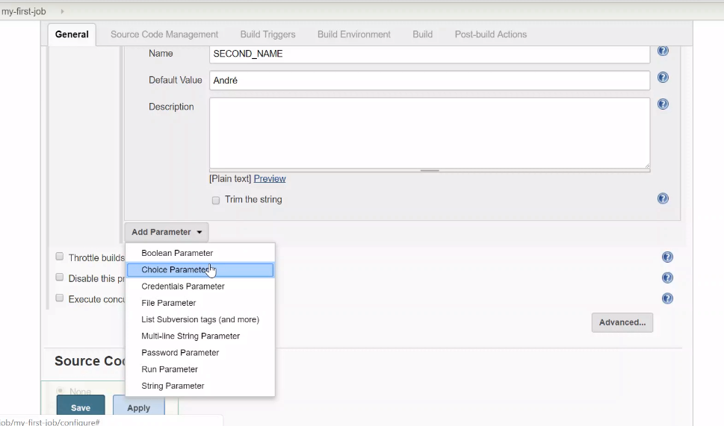
So we're going to give it a name which can be like last name for example any humor.
We're going to give choices.
So let's say the first last name is going to be like Smith.
Second one is going to be my last name.
One is going to be our random one and that's it.
Cool here in this case we have a parameter which is called last name in the list of values.
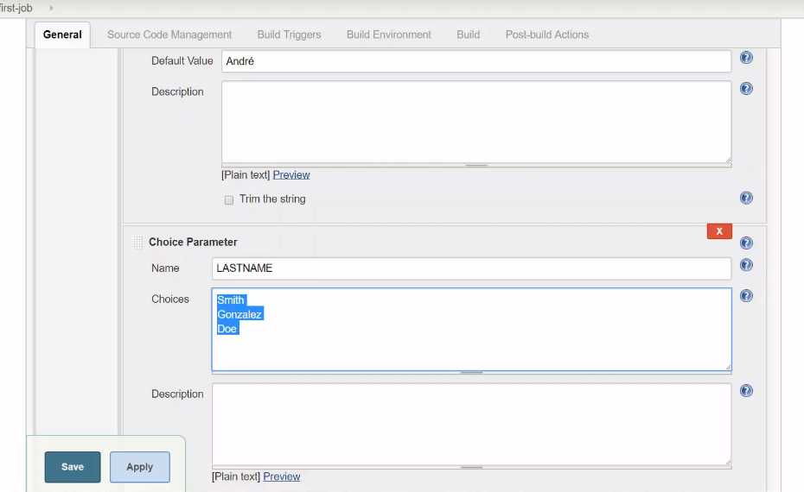
So depending on which value they use or picks up then these variables are going to take that value.
So let's make it clearer for example.
Now we have the first name now we have the second name.
And now what we need to do here is say like last name.
So let's save this and let's click can be permanent as you can see here we still have the first name
parameter which is a String parameter.
SECOND NAME IS the string parameters.
Well but if you want the last name that we just create is a list and if we click on this list we are
going to see the allowed Balios that we created before.
So the user can only choose one of these values.
So let's go ahead and use the last one.
And as you can see let's just give a random name here and click on Byard once the execution finishes
you are going to go here.
Cancel our booth and then you are going to see your hello.
The first parameter second Paramor and a third parameter that is the result of they choose another option
by that user.
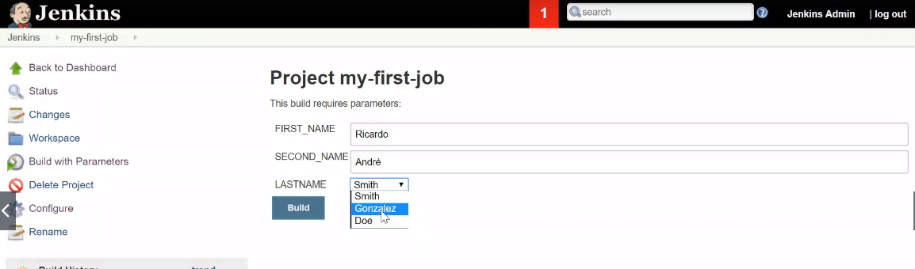
So as you could see we choose they do last name as the value for this parameter so let's click for example
in this let's hit built in after the execution finishes we're going to go into the output.
And as you can see here this group is actually taking the values that we are sending which is pretty
good.
So cool.
You already know how to create a string parameters.
How to you create list parameters and how to make your Jenkyns job to print those values.
This is pretty cool.
SEE YOU IN THE NEXT LIST.
And.

24. Add basic logic and boolean
parameters

